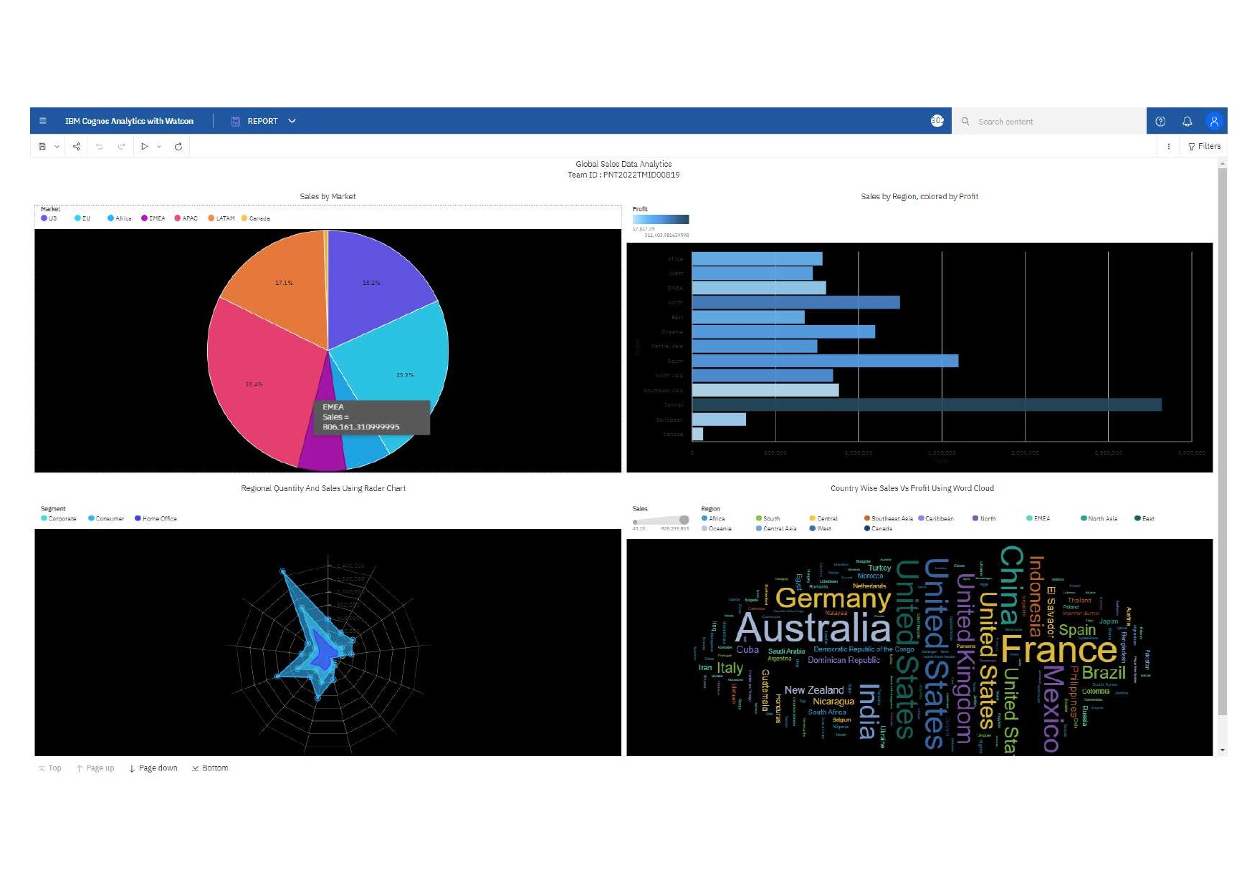

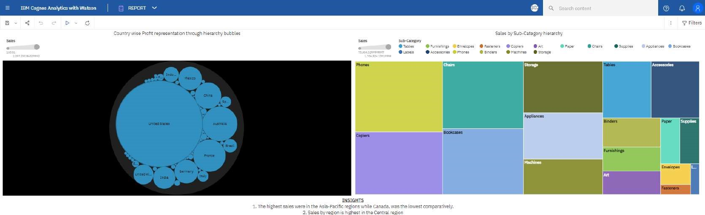by rezon is h:ghes: in the Central reg•on

2. Tho met profit wac oarned from tyc sub-zatagyy, electicnics,

4. IJ3is the main demanded market for the besiness

5, The avera\* Cdstu-ners the a-ost Who bcug-'t urcCucts lather than people buying offices or Corwrate people.

I. ways to sell such a: outlets can be hed in the region for enculcetirg more seles and profit.

2. Regions ;uch AS Canada least markets should hAAnÄtyæd ro ind reason h\*hind such pert6rmance. comparatively.

 3. marketing campainc could revolved around such low ales regvcnsfor a higher chance cf increasing customors, driving sales profit.

Top T Page up  down Hot'nm